WEEK 7
9. cricketapp
- Players.js
export function ListofPlayers({ players }) {
return (
<div>
{players.map((item, index) => (
<li key={index}>
Mr. {item.name} <span>{item.score}</span>
</li>
))}
</div>
);
}
export function Scorebelow70({ players }) {
const filtered = players.filter((item) => item.score <= 70);
return (
<div>
{filtered.map((item, index) => (
<li key={index}>
Mr. {item.name} <span>{item.score}</span>
</li>
))}
</div>
);
}

// In Players.js
export function OddPlayers({ players }) {
const [first, , third, , fifth] = players;
return (
<div>
<li>First : {first}</li>
<li>Third : {third}</li>
<li>Fifth : {fifth}</li>
</div>
);
}

export function EvenPlayers({ players }) {
const [, second, , fourth, , sixth] = players;
return (
<div>
<li>Second : {second}</li>
<li>Fourth : {fourth}</li>
<li>Sixth : {sixth}</li>
</div>
);
}
export function ListofIndianPlayers({ IndianPlayers }) {
return (
<div>
{IndianPlayers.map((player, index) => (
<li key={index}>Mr. {player}</li>
))}
</div>
);
}

- App.js
import React from 'react';

import { ListofPlayers, Scorebelow70, OddPlayers, EvenPlayers,ListofIndianPlayers } from './Players';

function App() {
const flag = true;

const players = [
{ name: "Jack", score: 50 },
{ name: "Michael", score: 70 },
{ name: "John", score: 40 },
{ name: "Ann", score: 61 },
{ name: "Elisabeth", score: 61 },
{ name: "Sachin", score: 95 },
{ name: "Dhoni", score: 100 },
{ name: "Virat", score: 84 },
{ name: "Jadeja", score: 64 },
{ name: "Raina", score: 75 },
{ name: "Rohit", score: 80 },
];

const IndianTeam = [
"Sachin1",
"Dhoni2",
"Virat3",
"Rohit4",
"Yuvaraj5",
"Raina6"
];

const T20Players = ['First Player', 'Second Player', 'Third Player'];
const RanjiTrophyPlayers = ['Fourth Player', 'Fifth Player', 'Sixth Player'];
const IndianPlayers = [...T20Players, ...RanjiTrophyPlayers];

if (flag === true) {
return (
<div>
<h1>List of Players</h1>
<ListofPlayers players={players} />
<hr />
<h1>List of Players having Scores Less than 70</h1>
<Scorebelow70 players={players} />
</div>
);
} else {
return (
<div>
<h1>Indian Team</h1>
<h1>Odd Players</h1>
<OddPlayers players={IndianTeam} />

<hr />
<h1>Even Players</h1>
<EvenPlayers players={IndianTeam} />
<hr />
<h1>List of Indian Players Merged:</h1>
<ListofIndianPlayers IndianPlayers={IndianPlayers} />
</div>
);
}
}
export default App;

Output:
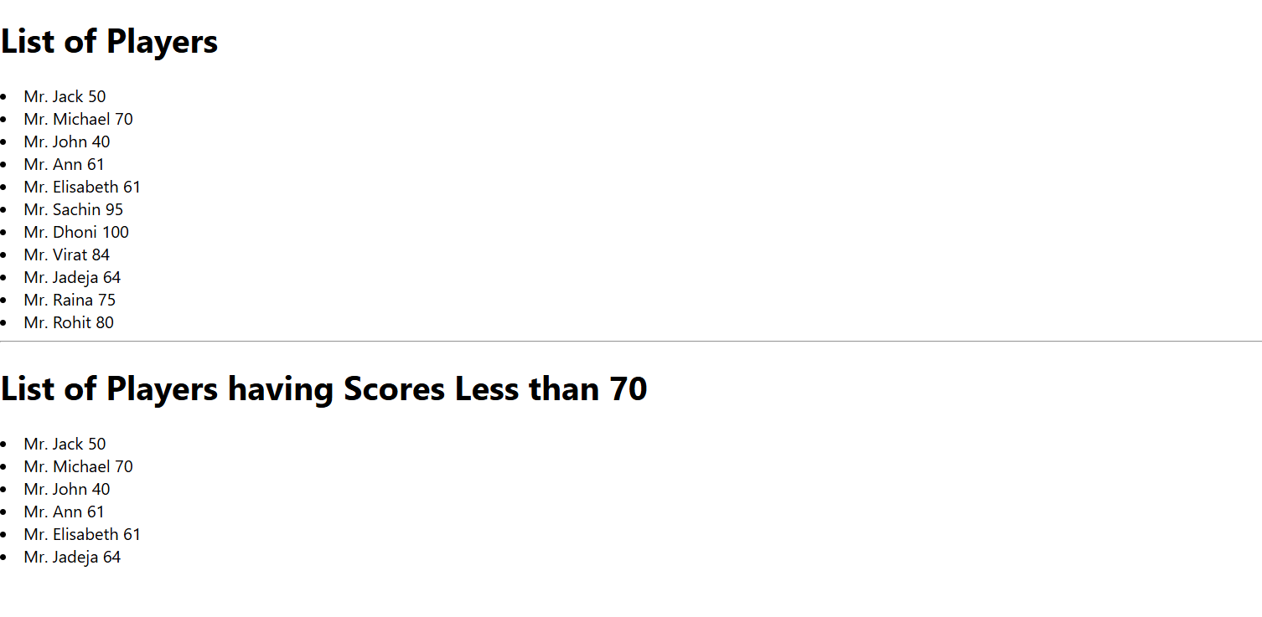
10. officespacerentalapp
- App.js
import './App.css';
const offices = [
{ Name: "DBS", Rent: 50000, Address: "Chennai", Image: "images/office1.jpg" },
{ Name: "Regus", Rent: 75000, Address: "Bangalore", Image: "images/office2.jpg" },
{ Name: "CoworkZone", Rent: 60000, Address: "Hyderabad", Image: "images/office3.jpg" }
];
function App() {
return (
<div>
<h1>🏢 Office Spaces at Affordable Range</h1>
{offices.map((item, index) => {
const rentClass = item.Rent <= 60000 ? 'textRed' : 'textGreen';
return (
<div key={index} className="box">
<img src={item.Image} width="25%" height="25%" alt="Office Space" />
<h2>Name: {item.Name}</h2>
<h3 className={rentClass}>Rent: Rs. {item.Rent}</h3>
<h3>Address: {item.Address}</h3>
</div>
);
})}
</div>
);
}
export default App;
Output:
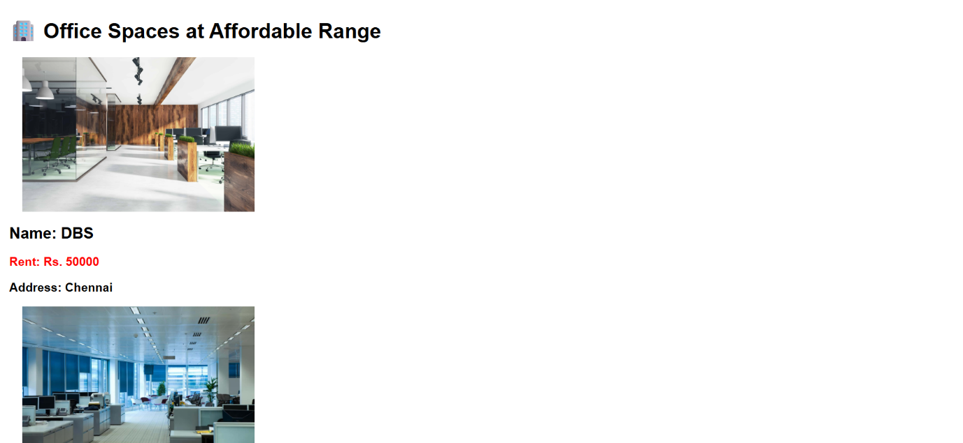
11. eventexamplesapp
- App.js
import './App.css';
import Counter from './Counter';
import Welcome from './Welcome';
import Hello from './Hello';
import CurrencyConvertor from './CurrencyConvertor';
function App() {
return (
<div style={{ margin: '20px' }}>
<Counter />
<Welcome />
<Hello />
<CurrencyConvertor />
</div>
);
}

export default App;

- Counter.js
import { useState } from 'react';

function Counter() {
const [count, setCount] = useState(0);
const increment = () => {
setCount(prev => prev + 1);
};

// Function to say hello with a static message
const sayHello = () => {
alert(`Hello Member ${count}`);
};

// Function that calls both actions
const handleClick = () => {
increment();
sayHello();
};
return (
<div>
<h1 id="number">{count}</h1>
<button onClick={handleClick}>Increment</button>
<button onClick={() => setCount(count -1)}>Decrement</button>
</div>
);
}

export default Counter;

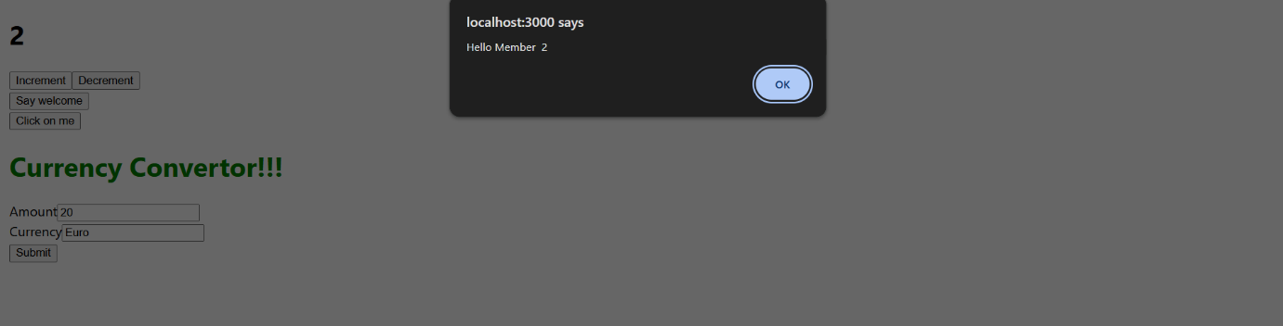
- Welcome.js
function Welcome() {

return (
<div>
<button onClick={() => alert('Welcome')}>Say welcome</button>
</div>
);
}

export default Welcome;

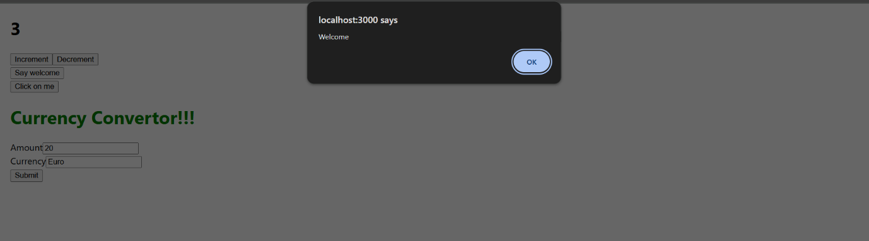
- Hello.js
function Hello() {

return (
<div>
<button onClick={() => alert('I was Clicked')}>Click on me</button>
</div>
);
}

export default Hello;

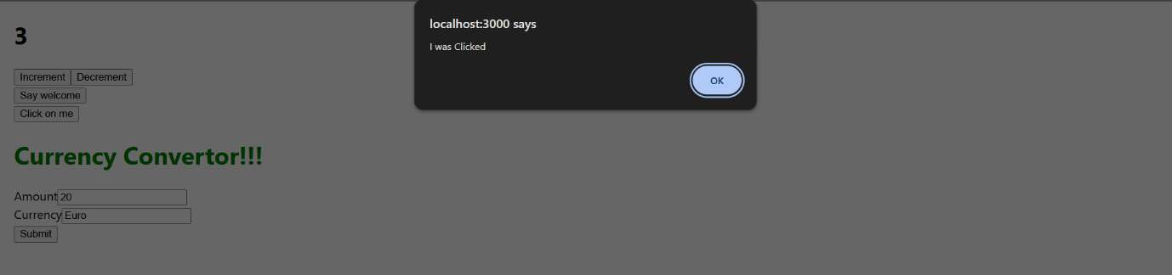
- CurrencyConvertor.js
import { useState } from 'react';
function CurrencyConvertor() {
const [amount, setAmount] = useState('');
const [currency, setCurrency] = useState('');
const handleSubmit = () => {
alert(`Converting ${amount} to ${currency}`);
};
return (
<div>
<h1 style={{ color: 'green' }}>Currency Convertor!!!</h1>
<label htmlFor="amt">Amount</label>
<input id="amt" type="number"
value={amount}
onChange={(e) => setAmount(e.target.value)}
/><br/>
<label htmlFor="currency">Currency</label>
<input id="currency" type="text"
value={currency}
onChange={(e) => setCurrency(e.target.value)}
/><br/>
<button onClick={handleSubmit}>Submit</button>
</div>
);
}
export default CurrencyConvertor;

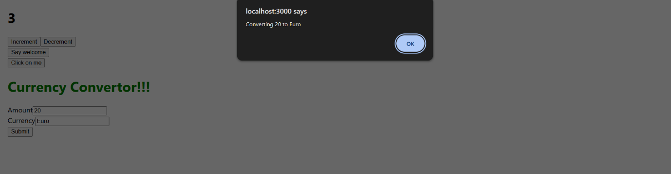
12. ticketbookingapp
- App.js
import React, { useState } from "react";

function LoginButton(props) {
return <button onClick={props.onClick}>Login</button>;
}

function LogoutButton(props) {
return <button onClick={props.onClick}>Logout</button>;
}

function UserGreeting() {
return (
<div>
<h1>Welcome back</h1>
<button>Book Ticket</button>
</div>
);
}

function GuestGreeting() {
return (
<div>
<h1>Please sign up.</h1>
</div>
);
}

function Greeting(props) {
const isLoggedIn = props.isLoggedIn;
if (isLoggedIn) {
return <UserGreeting />;
}
return <GuestGreeting />;
}

function App() {
const [isLoggedIn, setIsLoggedIn] = useState(false);
const handleLoginClick = () => setIsLoggedIn(true);
const handleLogoutClick = () => setIsLoggedIn(false);
let button = isLoggedIn ? (
<LogoutButton onClick={handleLogoutClick} />
) : (
<LoginButton onClick={handleLoginClick} />
);
return (
<div style={{ textAlign: "center", marginTop: "50px" }}>
<Greeting isLoggedIn={isLoggedIn} />
<div style={{ marginTop: "20px" }}>{button}</div>
</div>
);
}
export default App;

Output:
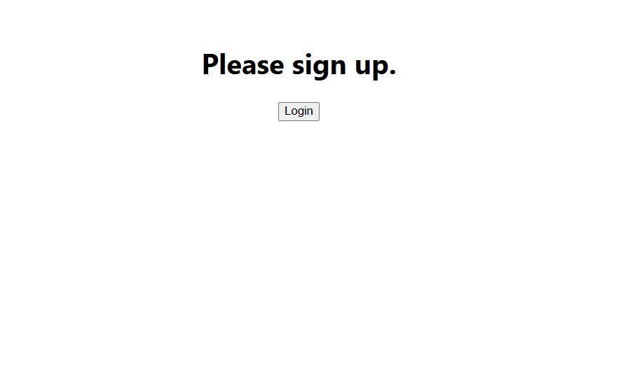
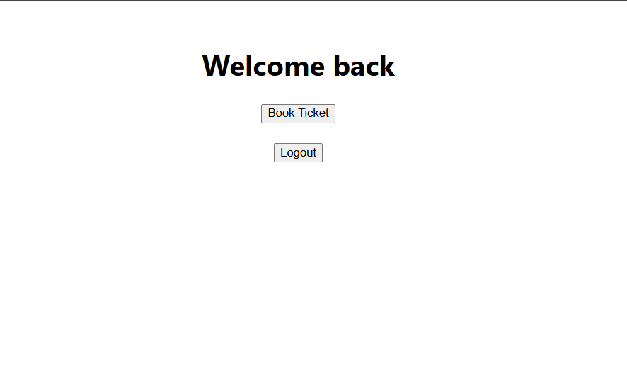
13. bloggerapp
- App.js
import React, { useState } from "react";
import { data } from "./data";
import "./index.css";

// Book Component (Ternary)
function BookDetails({ books, show }) {
return show ? (
<div className="section">
<h1>Book Details</h1>
{books.map((book) => (
<div key={book.id}>
<h3>{book.bname}</h3>
<h4>{book.price}</h4>
</div>
))}
</div>
) : null;
}

// Blog Component (&&)
function BlogDetails({ blogs, show }) {
return (
show && (
<div className="section">
<h1>Blog Details</h1>
{blogs.map((blog, i) => (
<div key={i}>
<h3>{blog.title}</h3>
<b>{blog.author}</b>
<p>{blog.content}</p>
</div>
))}
</div>
)
);
}
// Course Component (if-else)
function CourseDetails({ courses, show }) {
if (!show) return null;
return (
<div className="section">
<h1>Course Details</h1>
{courses.map((course, i) => (
<div key={i}>
<h3>{course.name}</h3>
<h4>{course.date}</h4>
</div>
))}
</div>
);
}
// Main App
function App() {
const [showBook, setShowBook] = useState(true);
const [showBlog, setShowBlog] = useState(true);
const [showCourse, setShowCourse] = useState(true);
return (
<div className="container">
<button onClick={() => setShowBook(!showBook)}>Toggle Books</button>
<button onClick={() => setShowBlog(!showBlog)}>Toggle Blogs</button>
<button onClick={() => setShowCourse(!showCourse)}>Toggle Courses</button>

<div className="sections">
<BookDetails books={data.books} show={showBook} />
<BlogDetails blogs={data.blogs} show={showBlog} />
<CourseDetails courses={data.courses} show={showCourse} />
</div>
</div>
);
}
export default App;

- data.js
export const data = {
books: [
{ id: 101, bname: "Master React", price: 670 },
{ id: 102, bname: "Deep Dive into Angular 11", price: 800 },
{ id: 103, bname: "Mongo Essentials", price: 450 },
],
blogs: [
{ title: "React Learning", author: "Stephen Biz", content: "Welcome to learning React!" },
{ title: "Installation", author: "Schwezdenier", content: "You can install React from npm." },
],
courses: [
{ name: "Angular", date: "4/5/2021" },
{ name: "React", date: "6/3/2021" },
],
};

- index.css
.container {
text-align: center;
margin: 20px;
}

.sections {
display: flex;
justify-content: space-around;
margin-top: 30px;
}

.section {
border-left: 3px solid green;
padding: 20px;
width: 30%;
text-align: left;
}

Output
